Action Plan
The J1100711 Group Training Course on
“IMPROVING TEACHING METHODS IN MATHEMATICS IN PRIMARY EDUCATION”

Name | Paul Mukwena
Country | South Africa
Organization | Norwood Primary School
Position | Head of Department for Mathematics and Natural Sciences

Title | Teaching Method ( Problem solving approach)
Period | 6 Months
Target Location | Norwood Primary School
Target Group | Students & Teachers
NARRATIVE SUMMARY
OVERALL GOAL
Year end exam results for mathematics is improved and learners are able to solve mathematics problems by themselves

SPECIFIC OBJECTIVES> (PROJECT PURPOSE)
The understanding of teaching mathematics methods on basic operations and content are improved for all the grades at school

YOUR LEARNING IN JAPAN
- Japanese system of Education
- Schooling system in Japan: Nursery, Elementary, Junior High School, Senior High School and University/College
- Curriculum: Mathematic Aims
- Curriculum: Overall Objectives: to foster their ability to think and represent everyday life ,w with good perspective and logically on matters of
willingly make use of mathematics in their daily lives as well as in their learning, to help pupils find pleasure in
mathematical activities and appreciate the value of mathematical approaches

- Curriculum Integration : Integrating natural disastrous such as Tsunami and Earth Quake in mathematics
- 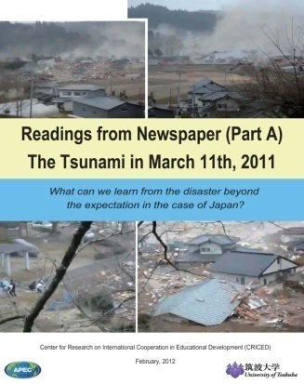
- Teacher Training System: how teachers are trained, how to acquire teaching license and the roles that are played by prefectures
- Lesson Study : process and the flow of lesson study
- System of Assessment
- Textbook Configuration
- Japanese Mathematics Content for Elementary School
School Education in Japan
Elementary Mathematics Curriculum Objectives
Sequence of Mathematics Textbooks : through manipulation learners understand and develop their own idea of calculation (Situation-Mathematical world- Expression ) or reversal of this peocess
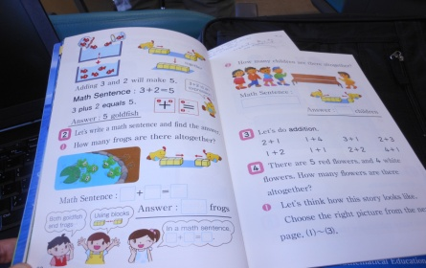
Statistical Literacy Examples from PISA

Blackboard Writing in Mathematics Lessons and how productive it is when used correctly, it reflects evidence of what have been learnt in the classroom, the ideas of learners are shown in the blackboard
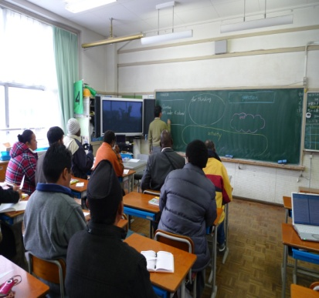
Ｄbook Software and Digital Textbooks

- Japanese Mathematics Method of Teaching

- Problem Posing & Solving Approach: Isoda and Murati, Grade 4, Pages 18 and 19)

- Japanese Problem Solving Approach
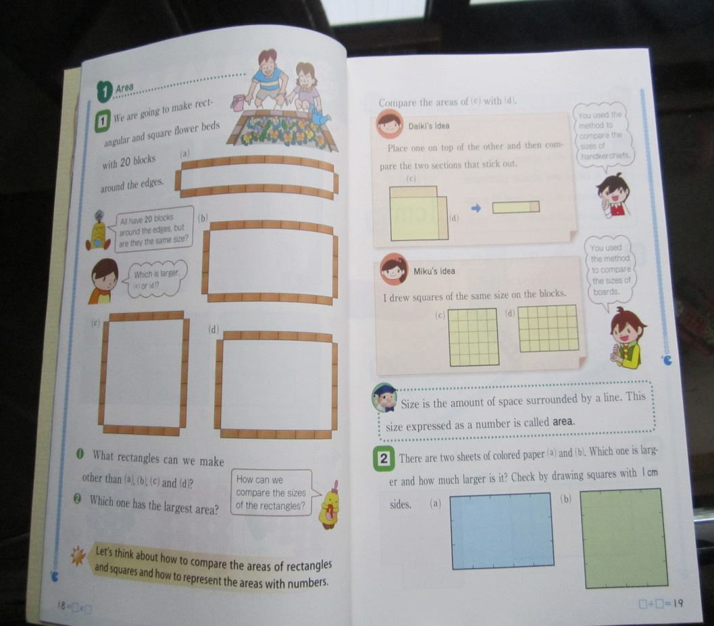
(ii) Example of Problem Solving Activities
- (iii) Questioning/ ‘Hatsumon’: This forms a very important of learning: Planned prior to class but can change through students’ ideas impact of hatsumon is usually discussed during post lesson discussion, “Isoda” What next?

- Teaching Materials
(i) d-books and e-books
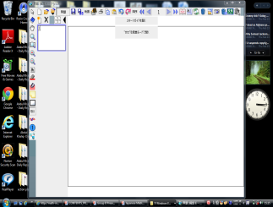
- models
FIRST THING FIRST
The outline of implementing the activities on my action plan
-Comprehensive report on what I have learned from Japan to the principal, staff and Mathematic s district official
- Workshop my teachers on method of teaching and analysing relevancy of contents from text books that we are using.
Share with my teachers the textbooks from Pro. Isoda
-Share the action plan with the Principal and Mathematics committee Teachers
-Introduce team lesson planning and interpreting of the Mathematics learning outcomes (Objectives) emphasis will be on why teachers should plan their own lesson plan and not rely on readymade lesson plan
-Introduce the lesson plan Study from school based and after the first trial I will invite seven neighbouring schools, namely; Houghton Primary, Asteri Primary, Rembrandt Park Primary, Linksfield Primary, Orchard Primary, Dr Knak and Orange Grove Primary
-Write a report after six months of the success of my action plan; come up with a way forward together with other educators from other schools

< OUTPUTS by applying your learning in Japan>
Output 1
The method of teaching mathematics outcomes, assessment standards and mathematics content is improved by all educators
Activities
Good quality of moderated mathematics worksheets
  - to prepare mathematics worksheets for all the grades
  - to develop a student activity work book
to conduct training on how to prepare a quality worksheet
  - to monitor and support educators in their planning
  - Maintain the standard of students who get high marks
  - Introduce lesson study as a way of improving learning and teaching at school

Output 2
The attendance of mathematics extra classes by students is improved
Activities
-1 to select students who can attend extra classes
2-2 Identify teachers who can offer mathematics extra classes
2-3 develop special worksheets for students who attend mathematics extra classes
2-4 support students who attend extra classes
2-5 graduate students who have shown great improvement in mathematics to
the expert group of students
2-6 Involve parents in supporting the students who attend extra classes
2-7 To support teachers in their attempt to improve mathematics achievement
2-8 To award students who do well in mathematics

Output 3
The work schedule which shows the guideline of teaching mathematics and topics to be covered is followed appropriately by all mathematics teachers
Activities
3.1 Develop a system of ensuring that mathematics content is covered
3-2 to review current challenges on covering the mathematics content
3-3 develop a model of communicating to the parents about how to support their children at home

Operation Plan
Output | Activities | Expected results | Time Schedule/Frame  In Months |  |  |  |  |  |  |  | Persons in  charge | Implementers | Resources/  Material | Budget | Remarks
Output | Activities | Expected results | 1 | 2 | 3 |  |  | 4 | 5 | 6 | Persons in  charge
Output 1  The umethod of teaching mathematics basic operation and contents is improved for all the grades at school | Good quality of moderated mathematics worksheets  - to prepare mathematics worksheets for all the grades  - to develop a student activity book  - to conduct training on how to prepare a quality study material.  - to monitor and support educators in their planning  - Maintain the standard of students who get high narks  1-6 Introduce lesson study as a way of improving learning and teaching at school | Teachers to use effective methods of teaching and begin to understand the national curriculum Education of South Africa. Improve the preparation of lesson. Effective use of the textbook.  Workshop on how to use teaching aids and Origami |  |  |  |  |  |  |  |  | Mr. Mukwena | Mathematic teachers  Grade 1-7  Ms. Dube  Mrs. Frank  Ms. Mkhonto  Mr. Sadiki  Ms. Maelane  Mrs. Motshegwa  Mr. Mukwena | Blackboard,  Whiteboard,  Overhead projector,  Charts,  Colored chalks. Mathematics Policy document | R10,000 | Achieved/Not achieved
2 The attendance of mathematics extra classes by students is very good | 1 to select students who can attend extra classes  2-2 Identify teachers who can offer mathematics extra classes  2-3 develop special worksheets for students who attend mathematics extra classes  2-4 support students who attend extra classes  2-5 graduate students who have shown great improvement in mathematics to  the expert group of students  2-6 Involve parents in supporting the students who attend extra classes  2-7 To support teachers in their attempt to improve mathematics method of teaching  2-8 To award students who do well in mathematics | Give learners opportunity to perform best according to their ability. To cultivate the love, Value and appreciation of Mathematics. |  |  |  |  |  |  |  |  | Mrs. Motshegwa | Mathematic teachers  Grade 1-7  Ms. Dube  Mrs. Frank  Ms. Mkhonto  Mr. Sadiki  Ms. Maelane  Mrs. Motshegwa  Mr. Mukwena | Record sheets | - | Achieved/Not achieved
3. The work schedule which shows the guideline of teaching mathematics and topics to be covered is followed appropriately by all mathematics teachers | .1 Develop a system of ensuring that mathematics content is covered  3-2 to review current challenges on covering the mathematics content  3-3 develop a model of communicating to the parents about how to support their children at home | Improvement in teaching all the concepts of Mathematics from the foundation phase |  |  |  |  |  |  |  |  | Mr. Mukwena  and Mrs. Motshegwa | Mathematic teachers  Grade 1-7  Ms. Dube  Mrs. Frank  Ms. Mkhonto  Mr. Sadiki  Ms. Maelane  Mrs. Motshegwa  Mr. Mukwena | -Policy document | - | Achieved/Not achieved

